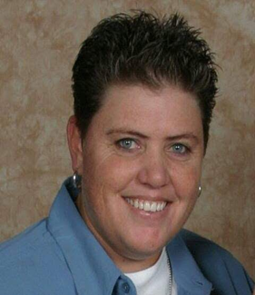Jo Miller, PLS

*Project Surveyor*

Jo is the President of True North Land Surveying, Inc., an SCS and DBE/WBE certified land surveying firm located in Seattle, WA. She has over 30 years of field and office experience with an emphasis on construction staking, environmental surveys, topographic surveys for design, railway, and utility surveys. Jo is responsible for processing, analyzing, and drafting survey data to assist with the creation of all types of land surveys. She remains on target and within budget while meeting client needs and deadlines. Her strong work ethic provides her the ability to communicate with her clients, which allows her to be comprehensive, judicious, and precise. Her broad and varied surveying knowledge allows her to effectively manage a variety of survey projects of all sizes and scope. Jo is the primary contact for her projects and makes herself readily available to her clients to assist with questions, guidance on the project, and in resolving any issues that may arise with the project.

Prior to scheduling crews for field work, Jo will review the project scope to ensure that she fully understands the scope and what exactly is needed to fulfill client needs and requests for the specific project. If there is any clarification needed on the scope she will reach out to the client, prior to sending a crew out to the field, to gain a better understanding of the scope and offer her expertise as needed. She strives to be very proactive on the projects she manages. One way she does this is by maintaining open communication with the field crew while they are on-site and with the client. Her frequent communication with the client enables her to keep them informed on the progress of the project. With this open and regular communication, she is better able to help identify any potential issues and/or problems that may arise from anticipated surveying needs to the coordination in the field that may be needed. Jo will see her projects through to the very completion and delivery of final product to the client. Her attention to detail and thorough review of all work ensures that the final product clients receive is of the highest quality and accurately meeting all the clients’ requests and needs.

By developing her strong level of open communication with field crews, she is able to stay up to date on project progress and ensure the field work is meeting the scope of work requirements while maintaining the set budget for the project. As more work is requested and/or problems arise in the field, beyond the control of True North, Jo will ensure there is budget available on the project to cover the additional work. In instances where issues in the field, beyond control, and/or added scope is not covered by the current budget set she will contact the client to discuss budget needs and adjustments pertaining to the current situation.

Firm:

True North Land Surveying, Inc.

Years of Experience:

30+ years

Education:

A.A., Associate of Science, BCCC

(Kansas), 1991

Registration(s):

Professional Land Surveyor:

WA # 20118394, 2020

**Key Skills:**

* Topographic Surveys
* Construction Staking
* Settlement Monitoring
* Elevation Surveys
* Environmental Surveys
* Utility Surveys
* Budget Management
* Project Management
* Scheduling Flexibility
* Safety Conscious
* QA/QC Manager
* Public Entity Working Experience & Familiarity

Revised: 11/4/24